Set Up and Connection to the CS Firewall via L2TP/IPsec
Windows
- Open the Start Menu and go to Settings>Network & internet>VPN
- Click “Add VPN”
  - 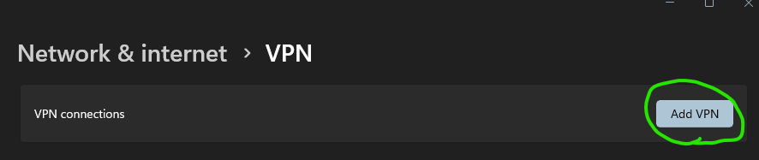
- The connection name can be whatever you would like, in the example below I call it “CS VPN”
- The server address is 147.64.2.12
- The Pre-shared key as well as your username and password can be found in the “credentials.txt” file. Click “Save” when you are done.
  - 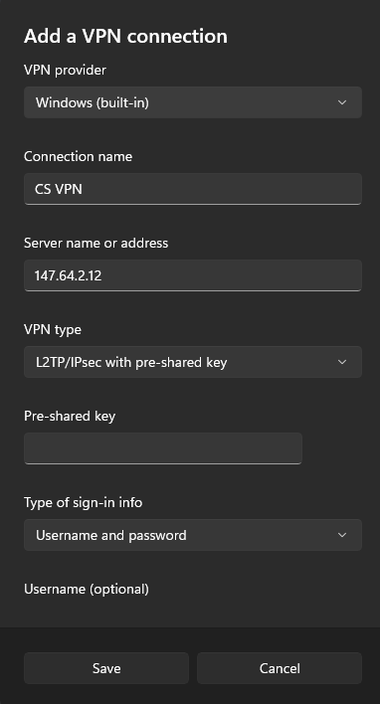

- Go back to the VPN menu, you should now see an entry for the “CS VPN” or whatever name you chose
  - 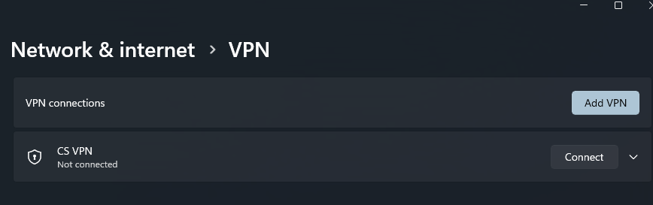
  - Click “Connect”
- You are now connected to the CS VPN and can access resources inside the CS network.
- To disconnect, return to the VPN menu and click “Disconnect”

MacOS
- Open System Preferences and go to Network
  - Click the three dots in the bottom right corner, then highlight “Add VPN Configuration”>L2TP over IPSec…
  - 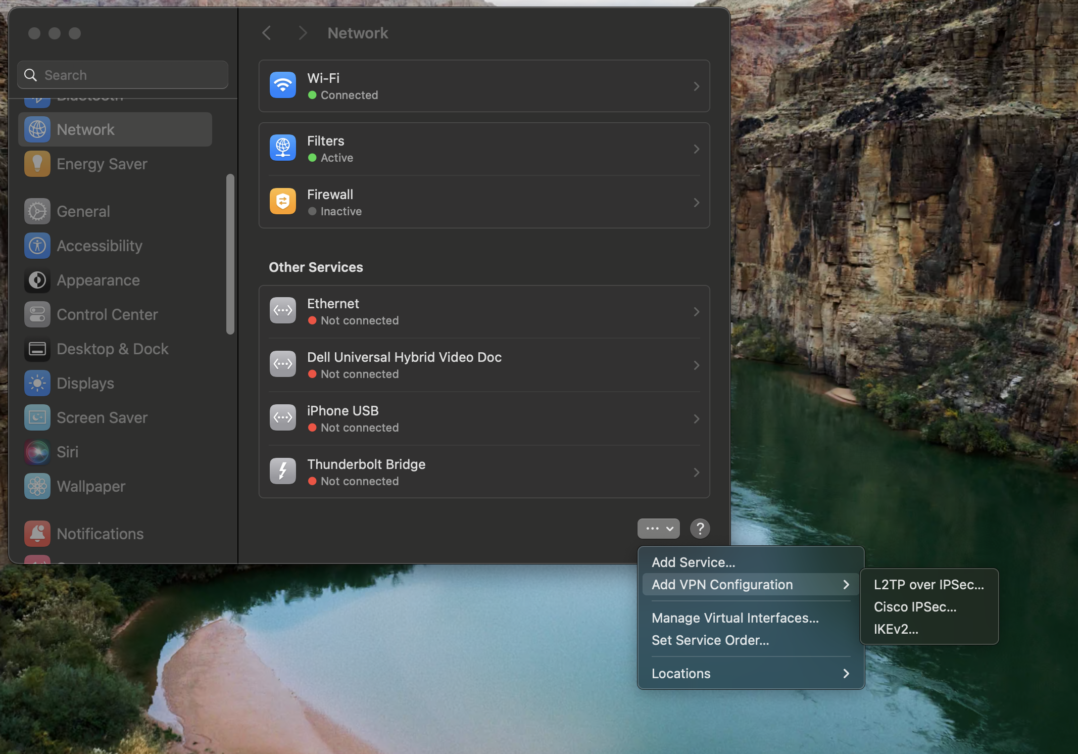

  - 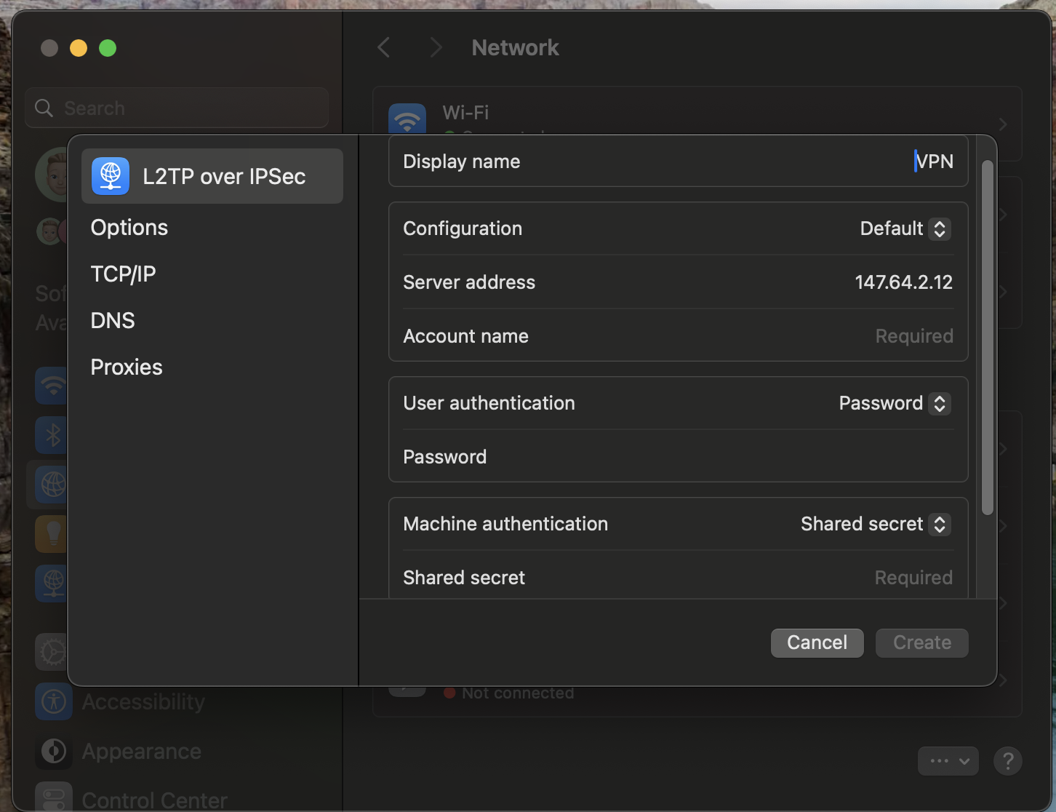

  - The display name can be whatever you would like, in the example above it’s just called “VPN”
  - The server address is 147.64.2.12
  - The Pre-shared key as well as your username and password can be found in the “credentials.txt” file. Click “Create” when you are done.
  - Return to system preferences and Click on “VPN”
  - Toggle the switch on to connect.
- You are now connected to the CS VPN and can access resources inside the CS network.
- To disconnect, return to the System Preferences>VPN menu and toggle the switch to the off position.

